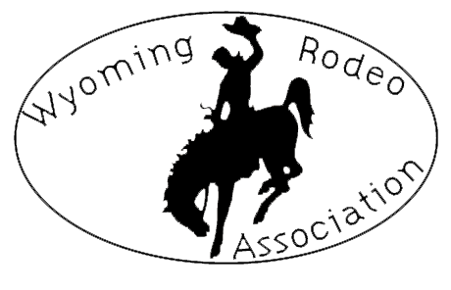
Co Sanction Approval Form
Wyoming Rodeo Association
Phone: (307) 331-5913
P.O. Box 1142, Laramie, WY 82073
Email: wyomingrodeoassociation@yahoo.com
Website: www.wyorodeoassociation.com

Date of Rodeo:

Rodeo Name:

Location:

Performance Times:

Slack Times:

Events:

Entry Fees:

Added Money:

Stock Contractor:

Central Entry (Date-Time-Phone #):

Call Back (Date-Time):

Extra Activities: ___________________________________________________________

Stalls/Over Night Parking? YES NO

Signature of Committee Member Date

Approved by WRA Date

